BubbleSort Analysis Sheet
Number List Size | 10 100 1000 | 10000 | 100000 | 1000000
Miliseconds | 0 0 27 | 312 | 30720 | 3430563
Swaps 24 2765 246734 25026299 2481035035 247375710056
Comparisons 45 4950 499500 49995000 4999950000 499999500000

Average Time (Miliseconds): 576937 (9.61561667 Minutes)
Number of Comparisons/Swaps
Miliseconds
Comparison & Swap Numbers Based on List Size  600000000000  400000000000  200000000000  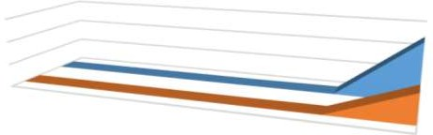        0  Comparisons  Swaps  Number List Size  Swaps Comparisons | 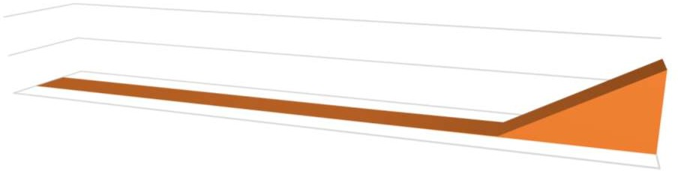  4000000  2000000  0 | 10 | 100 | Miliseconds Taken Based on List Size  1000  10000  100000  Number List Size  Miliseconds | Miliseconds 1000000
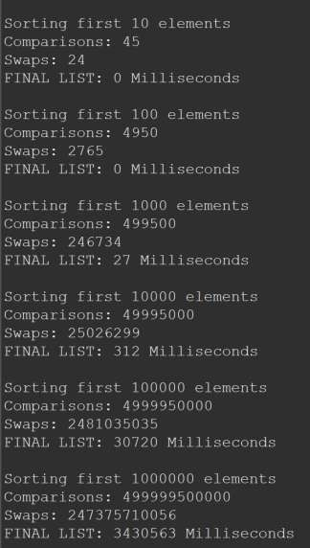
Output: Analysis Notes:
This method isn't exactly the most efficient when it comes to larger quantities of data. It succeeds in both time and comparison/swap efficiency until the number size gets to be about 100000. In the smaller number lists, the time is under 1 second, the swap and comparison numbers do increase but not enough to degrade the time. After 100000, the times are 30.72 seconds (100000) and 57.17605 minutes (1000000). In addition to this, the swap and comparison numbers get so large you have to change the data types from integers to longs. Collecting the data wasn't much of a challenge for me, it took a while for the 1000000 number list (see 57.17605 time), but this could be an issue if this was a program a company wanted to use to sort data. Also, if the computer that's being used to sort the data doesn't have a powerful enough processor, the program can crash, resulting in potential data loss. For better efficiency, I suggest using a method that doesn't need to compare the same item multiple times and can instead sort the number into its place (for example: Selection Sort or Quick Sort).

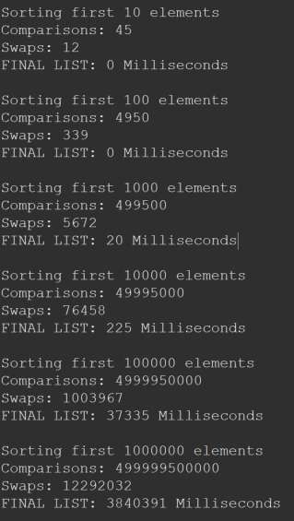
SelectionSort Analysis Sheet
Number List Size | 10 | 100 | 1000 | 10000 | 100000 | 1000000
Miliseconds | 0 | 0 | 20 | 225 | 37335 | 3840391
Swaps | 12 | 339 | 5672 | 76458 | 1003967 | 12292032
Comparisons 45 4950 499500 49995000 499995000 499999500000

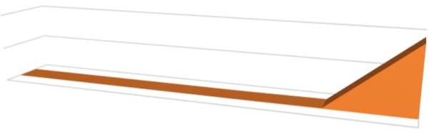
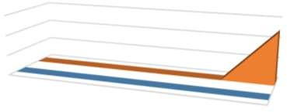


Average Time (Milliseconds) 646329 (1.07215 minutes)
Miliseconds
Number List Size
1000000
100000
Miliseconds
10000
1000
100
10
4000000

2000000

0
Milliseconds Taken Based on List Size
Swaps Comparisons
Number List Size
Swaps
600000000000
400000000000
200000000000
0
Comparisons and Swaps Based On List Size
Milliseconds
Axis Title
Milliseconds
Axis Title

Output: | Analysis:
 | This method isn't still the most
 | efficient when it comes to larger
 | quantities of data. It succeeds in
 | both time and comparison/swap
 | efficiency until the number size
 | gets to be about 100000. In the
 | smaller number lists, the time is
 | under 1 second, the swap and
 | comparison numbers do increase
 | but not enough to degrade the
 | time. After 100000, the times are
 | 37.335 seconds (100000) and
 | 64.00651 minutes (1000000).
 | Collecting the data wasn't much
 | of a challenge for me, it took a
 | while for the 1000000 number
 | list (see 64.00651 time), but this
 | could be an issue if this was a
 | program a company wanted to
 | use to sort data. Also, if the
 | computer that's being used to
 | sort the data doesn't have a
 | powerful enough processor, the
 | program can crash, resulting in
 | potential data loss. For better
 | efficiency, I suggest using a
 | method that doesn't need to
 | compare the same item multiple
 | times and can instead sort the

BubbleSort Graphs:
Number of Comparisons/Swaps
Miliseconds

Comparison & Swap Numbers Based on List Size  500000000000  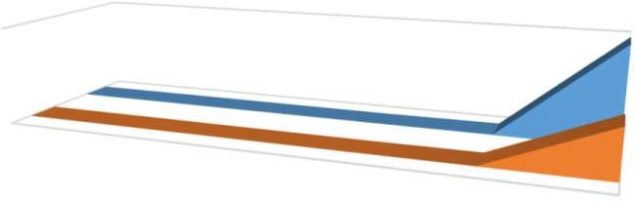  0  10 100  1000  10000  100000  Number List Size  Swaps Comparisons | Comparisons Swaps  1000000 | 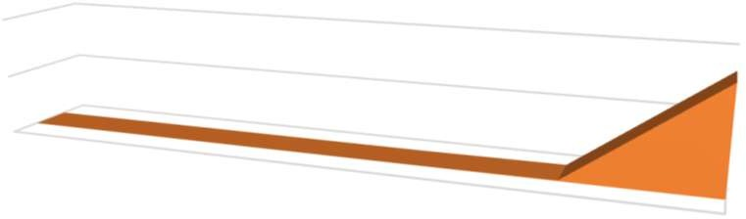  4000000  2000000  0 | 10 | Miliseconds Taken Based on List Size  100  1000  10000  100000  Number List Size  Miliseconds | Miliseconds 1000000
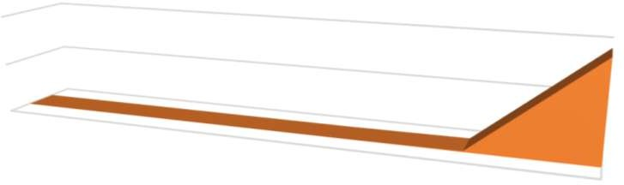
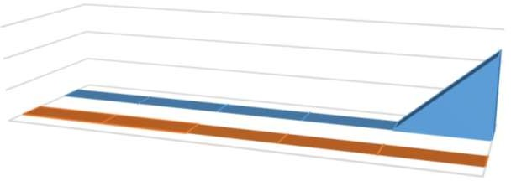
Selection Sort Graphs:
Miliseconds
Number List Size
1000000
100000
Miliseconds
10000
1000
100
10
0
4000000

2000000
Milliseconds Taken Based on List Size
Swaps Comparisons
Number List Size
1000000
100000
10000
Comparisons
Swaps
1000
100
10
600000000000
400000000000
200000000000
0
Comparisons and Swaps Based On List Size
Milliseconds
Axis Title
Milliseconds
Axis Title

Comparison Analysis:

Both methods are not the most efficient when it comes to larger quantities of data. However, it seems to be that BubbleSort does better with time, having shorter times. SelectionSort succeeds in comparison and swap numbers. They both succeed in time and comparison/swap efficiency until the number size gets to be about 100000. In the smaller number lists, the time is roughly under 1 second, the swap and comparison numbers do increase but not enough to degrade the time. After 100000, the times are much longer though, taking about 30 seconds to an hour. However, at larger numbers, the Selection Sort does significantly better at keeping swap/comparison numbers low.

